How to Download & Install Linux (Ubuntu) in Windows

There are hundreds of Linux operating systems or Distributions available these days.

* Ubuntu. ...
* Fedora. ...
* Linux Mint. ...
* openSUSE. ...
* PCLinuxOS. ...
* Debian. ...
* Mandriva. ...
* Sabayon/Gentoo

| **Linux Distributions** | **Name** | **Description** |
| --- | --- | --- |
| <https://www.guru99.com/images/ArchLinux.png> | **Arch** | This Linux Distro is popular amongst Developers. It is an independently developed system. It is designed for users who go for a do-it-yourself approach. |
| <https://www.guru99.com/images/centos.png> | **CentOS** | It is one of the most used Linux Distribution for enterprise and web servers. It is a free enterprise class Operating system and is based heavily on Red Hat enterprise Distro. |
| <https://www.guru99.com/images/debian.png> | **Debian** | Debian is a stable and popular non-commercial Linux distribution. It is widely used as a desktop Linux Distro and is user-oriented. It strictly acts within the Linux protocols. |
| <https://www.guru99.com/images/fedora.png> | **Fedora** | Another Linux kernel based Distro, Fedora is supported by the Fedora project, an endeavor by Red Hat. It is popular among desktop users. Its versions are known for their short life cycle. |
| <https://www.guru99.com/images/gentoo.png> | **Gentoo** | It is a source based Distribution which means that you need to configure the code on your system before you can install it. It is not for Linux beginners, but it is sure fun for experienced users. |
| <https://www.guru99.com/images/LinuxMint.png> | **LinuxMint** | It is one of the most popular Desktop Distributions available out there. It launched in 2006 and is now considered to be the fourth most used Operating system in the computing world. |
| <https://www.guru99.com/images/OpenSuse.png> | **OpenSUSE** | It is an easy to use and a good alternative to MS Windows. It can be easily set up and can also run on small computers with obsolete configurations. |
| <https://www.guru99.com/images/redhat(2).png> | **RedHat enterprise** | Another popular enterprise based Linux Distribution is Red Hat Enterprise.It has evolved from Red Hat Linux which was discontinued in 2004. |
| <https://www.guru99.com/images/slackware.png> | **Slackware** | Slackware is one of the oldest Linux kernel based OS's. It is another easy desktop Distribution. It aims at being a 'Unix like' OS with minimal changes to its kernel. |
| <https://www.guru99.com/images/ubuntu_logo.png> | **Ubuntu** | This is the third most popular desktop operating system after Microsoft Windows and Apple Mac OS. It is based on the Debian Linux Distribution, and it is known as its desktop environment. |

**Installing Linux using USB stick**

This is one of the easiest methods of installing Ubuntu or any distribution on your computer. Follow the steps.

Step 1) Download the .iso or the OS files on your computer .

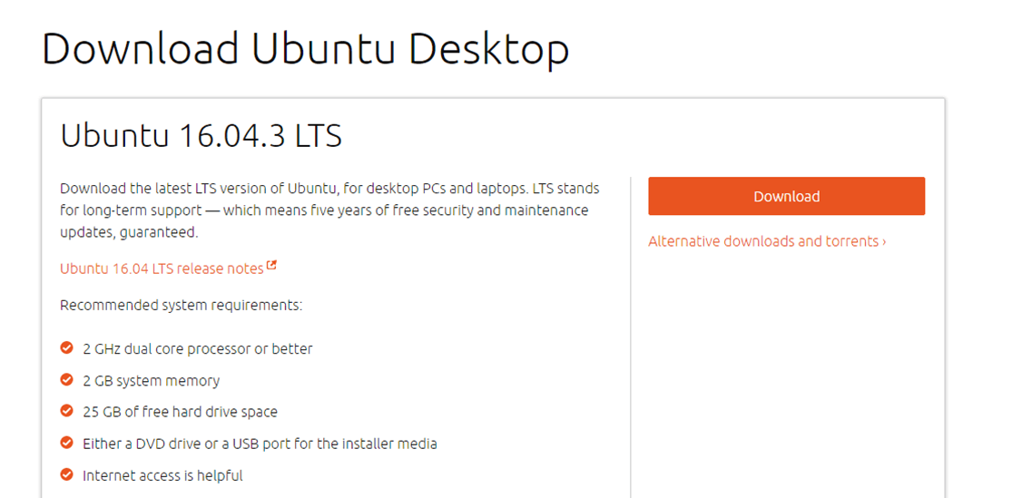

Step 2) Download free software like 'Universal USB installer to make a bootable USB stick.

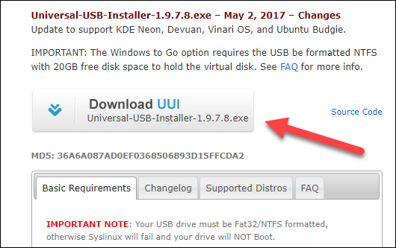

Step 3) Select an Ubuntu Distribution form the dropdown to put on your USB

Select your Ubuntu iso file download in step 1.

Select the drive letter of USB to install Ubuntu and Press create button.

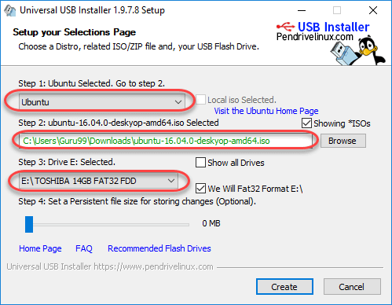

**Step 4)**Click YES to Install Ubuntu in USB

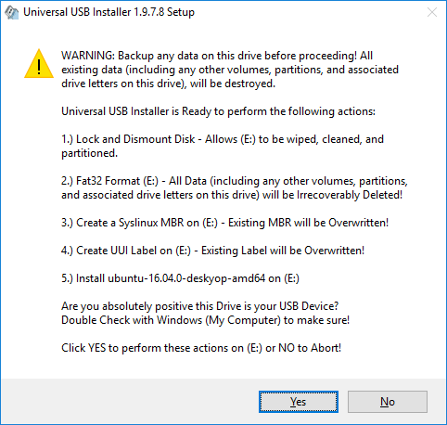

**Step 5)**After everything has been installed and configured, a small window will appear Congratulations! You now have Ubuntu on a USB stick, bootable and ready to go.

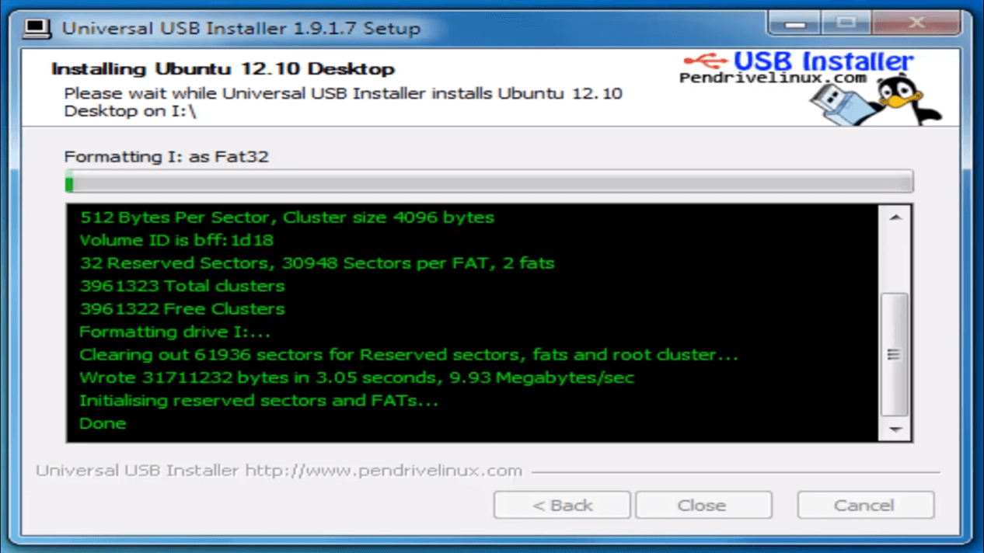

**Installing Linux using CD-ROM**

Those who like the way a CD runs should try using this method.

. 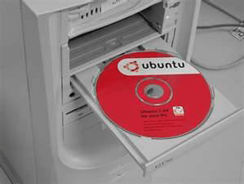

**Step 1)**Download the .iso or the OS files onto your computer from this link <http://www.ubuntu.com/download/desktop>.

**Step 2)**Burn the files to a CD.

**Step 3)**Boot your computer from the optical drive and follow the instructions as they come.

### Installing Linux using Virtual Machine

This is a popular method to install a Linux operating system. The virtual installation offers you the freedom of running Linux on an existing OS already installed on your computer. This means if you have Windows running, then you can just run Linux with a click of a button.

**Here the brief steps**

[](https://www.guru99.com/images/2-2017/092017_0628_Ubuntuinsta1.png)

**PART A) Download and Install Virtual Box**

Depending on your processor and OS, select the appropriate package. In our case, we have selected Windows with AMD.

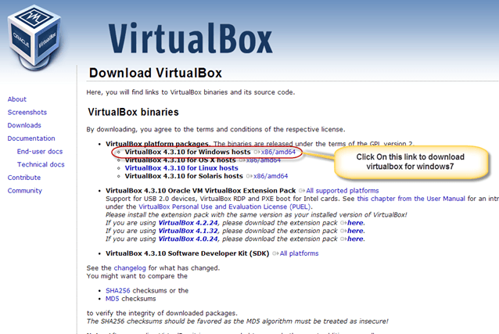

Once the download is complete, Open setup file and follow the steps below:

**Step-1)**Click On next

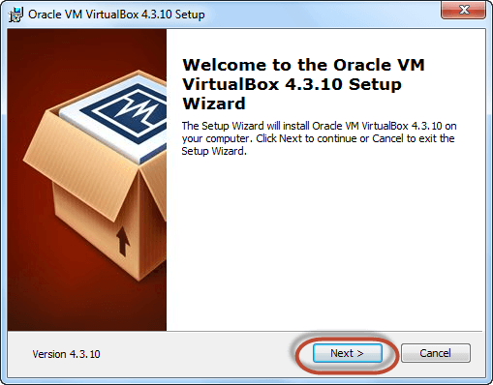

**Step-2)**Select you're the directory to install VirtualBox and click on next

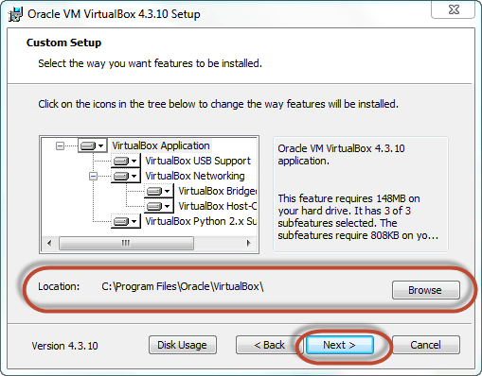

**Step-3)**Select Desktop icon and click on next, now click on yes

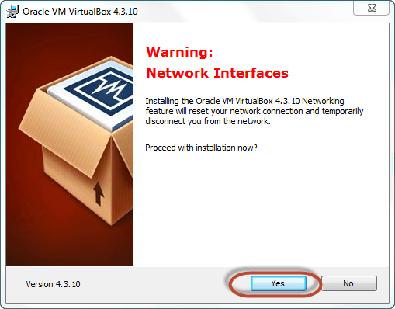

**Step-4)**Click On install.

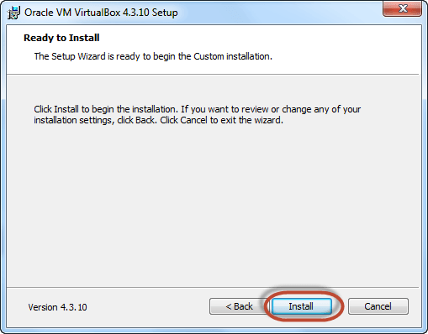

**Step-5)**Now installation of the virtual box will start. Once complete, click on Finish Button to start Virtual Box

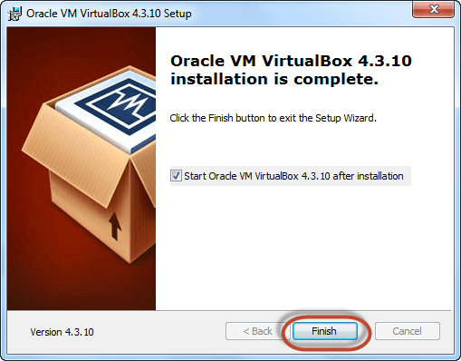

The virtual box dashboard looks like this-